NETWORK FUNDAMENTALS AND BUILDING NETWORKS

WIRELESS NETWORKING

TAASK1: List 3 popular Wi-Fi standards (e.g., 802.11n, 802.11ac, 802.11ax) and for each, write one key difference in speed or frequency band.
Wi-Fi Standard | Frequency Band | Key Difference
802.11n (Wi-Fi 4) | 2.4 GHz and 5 GHz | Supports speeds up to 600 Mbps.
802.11ac (Wi-Fi 5) | 5 GHz | Faster than 802.11n, supports speeds up to 3.5 Gbps.
802.11ax (Wi-Fi 6) | 2.4 GHz and 5 GHz (also 6 GHz in Wi-Fi 6E) | Provides higher speed, better performance, and supports many connected devices efficiently.

TASK2: Draw a simple diagram (on paper or using any drawing tool) showing how your smartphone connects to the internet via a Wi-Fi router at home, labeling the wireless and wired parts of the network.
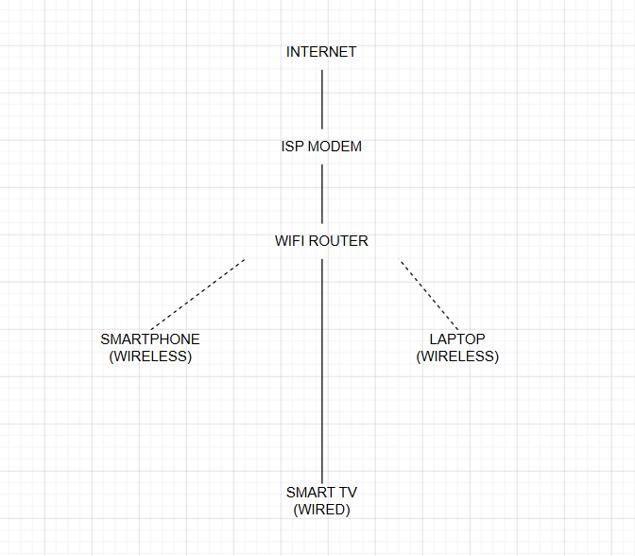
TASK3: Scan for available Wi-Fi networks using your laptop or phone, note down the SSID, signal strength, and security type (WPA2, WPA3, etc.) for at least 3 networks, and explain which one you would choose and why.<br><br><em><strong>Hint:</strong> Consider both signal strength and security when choosing.</em>

SSID (Wi-Fi Name) | Signal Strength | Security Type
Home_WiFi | Excellent (90%) | WPA2-Personal
JioFiber | Good (75%) | WPA3-Personal
Airtel_Xstream | Fair (55%) | WPA2-Personal
I would choose JioFiber because it has a good signal strength and uses WPA3 security, which is more secure than WPA2. It provides better protection for the network while maintaining a stable connection.

TASK4: Explain in your own words what 'SSID hiding' is in Wi-Fi networks and discuss one advantage and one disadvantage of hiding your Wi-Fi SSID.

SSID hiding means the Wi-Fi network name is not shown in the list of available networks. Users must enter the Wi-Fi name (SSID) manually to connect.
- ADVANTAGE: It makes the Wi-Fi network less visible to other people and may reduce unwanted connection attempts.
- DISADVANTAGE: It does not provide strong security because the network can still be detected using network scanning tools. It can also make it less convenient for users to connect.
SSID hiding provides a small amount of privacy, but it should always be used together with strong Wi-Fi security such as WPA2 or WPA3.

